**SPECIFIC AIMS**

The discovery of amphibole asbestos (AA) in dusts generated in anthropogenically-disturbed areas of southern Nevada, near very large population areas [1-3], demands that focused efforts are applied to investigating the public health risk. Two recent discoveries highlight this need. First, it has become abundantly clear that the vast majority of studies on asbestos have focused on commercial asbestos in which serpentine (chrysotile) asbestos is predominant. Thus, exposure standards are based on occupational exposures, which tend to be high, and on cancer outcomes which are predominant with chrysotile. However, environmental exposures are often amphibole asbestos, which has been less studied but has severe health consequences at low exposure levels [4-7], leading to much lower proposed exposure standards [8]. Second, asbestos must now be considered as part of the human exposome, a component of lifetime exposures that may impact health even at low concentrations such as those occurring world-wide from airborne fibers released by construction, road building, recreation, or dust storms [1, 2, 10-12]. As the climate warms and dries, this is becoming a highly significant public health issue [13]. A key example is emerging in the southwestern U.S., as follows.

A high level of concern exists about exposure to Naturally Occurring Asbestos (NOA) in Southern Nevada (NV), an area that is home to 2.02 million residents [14] and 45 million visitors annually [15]. Our team, and a Citizen Action Group (CAG) formed in 2014, created broad awareness of NOA in housing developments, school yards, and recreational areas [1, 2, 16, 17]. However, the health risks of NOA remain unknown, as it is well established that different forms of asbestos can have very different health outcomes, requiring that newly discovered mineral fibers be assessed for their specific health effects. Until we truly understand the pathogenicity determinants of asbestos, we propose that we will gain the most through fiber comparison studies in mice [18].The experience at the Libby MT Superfund Site has taught us that non-cancer pleural disease is the most prevalent outcome from AA, having massive effects on public health [5, 19, 20]. The pleural disease seen with Libby Amphibole (LAA) is associated with pain, progressive loss of lung function, and death [5, 21-23]; outcomes not generally reported with chrysotile [24-27]. Further, LAA is associated with autoimmune outcomes in mice and humans [9, 28-31]. Therefore, the assessment of potential health outcomes of NOA exposure must take into account the fiber mineralogy, chemistry and morphology. Historically, hypotheses regarding pathogenicity have focused heavily on fiber size [32-34]. Due to their focus on commercial asbestos, most regulatory standards are based on fibers that are at least 10 microns long and completely disregard very short fibers. Our preliminary data suggest that, for non-cancer outcomes, very small fibers may be highly impactful. If so, a completely new look at regulatory standards for mineral fibers must be considered. Due to our extensive experience with LAA, we are optimally poised to propose this study of newly discovered AA fibers from Nevada (NvAA), Arizona (AzAA), and Minnesota/Wisconsin (MnAA), compared to the well-studied LAA. **Our over-arching hypothesis is that the presence of very small fibers drives the immunotoxicity of asbestos in ways never before examined, impacting non-cancer outcomes.**

Aim 1: Develop a detailed comparison of fiber morphology, chemistry and morphology of the four samples (LAA, NvAA, AzAA, MnAA) with particular attention to the frequency of very small (how small?) fibers.

a) Perform water elutriation of all raw samples to create respirable fractions.

b) Determine median fiber sizes, plus mineralogy and chemistry of the samples.

Aim 2: Use equal-mass and equal-surface area (SA) in vitro exposures to assess the impact of relative median surface area (and therefore fiber size) on toxicity and activation of splenocytes and macrophages from mice.

a) Measure T helper cytokine subsets in post-exposure culture fluid from spleen cells.

b) Measure cell toxicity, oxidative stress and DNA damage as indices of inflammatory and carcinogenic

potential.

Aim 3: Use equal-surface area exposures in mice to assess health outcomes

a) Pulmonary outcomes (interstitial and pleural fibrosis)

b) Autoimmune outcomes (autoantibodies and white blood cell subsets)

Mineral fibers that do not meet the strict regulatory definition of “asbestos” can have severe health consequences [35-38]. This leaves us without safety standards for current public health hazards such as NOA. Recently, a new reference concentration (RfC) was established based on a LAA-specific risk assessment that showed non-cancer health outcomes at very low exposures [8]. The proposed study will determine the pathogenicity determinants behind this dramatic outcome. This study is therefore timely and relevant for many stakeholders, including EPA, CDC/ATSDR, NIOSH, land managers, and State and local governments.

**Research Strategy**

**(a) Significance**

The vast majority of work performed historically on asbestos has studied only the commercial forms of asbestos and has focused on cancer and asbestosis as outcomes at mostly occupational exposure doses. Due to new discoveries, this is no longer appropriate [38]. Fibrous minerals not previously recognized as asbestos must now be recognized as a part of the human "exposome", a component of lifetime exposures that may impact health even at low concentrations such as those occurring world-wide from airborne fibers released by construction, road building, recreation, or dust storms [1, 2, 10-12]. As the climate warms and dries, this is becoming a highly significant public health issue [13]. What is needed is a paradigm shift in the way we evaluate health effects of exposure to fibrous dusts.

This statement is based on two important recent discoveries. First, data have clearly shown that mineral fibers that do not meet the strict regulatory definition of “asbestos” nevertheless have serious health consequences [35-37], including mesothelioma, pulmonary carcinoma, and a variety of fibrotic pulmonary and pleural diseases [37-42]. Second, many studies demonstrate that environmental asbestos exposure is quite commonly environmental, broadly exposing populations around the world and impacting health [1-3, 10, 43-49]. Additionally, our research indicates that fibrous amphiboles occur in rocks and soils not previously expected to contribute to asbestos formation [1], which suggests that additional exposures are yet to be identified. Asbestos particles become airborne when soils that naturally contain asbestos minerals are disturbed either through anthropogenic activities and/or natural wind erosion [1]. It has been estimated that a cubic meter of ambient air contains 300 million particles that are between 0.01 and 0.1 microns in diameter [50]. These small particles are “respirable”, meaning that they are breathed deep into the lung. Arid climates have even higher concentrations of mineral dust [1, 51]. Exposure to mineral dust is especially a concern in the American Southwest due to a combination of current and predicted increases in aridity [13] and explosive population growth, which is expected to increase into the future, with an estimated 19 million more people by 2030 (from 2010) [52] (Figure 1).

A specific example of this concern is the discovery of AA in rocks and soils over a broad region in and around the greater Las Vegas metropolitan area [1-3], where over 2 million people reside. Anthropogenic activities including road construction, solar power plant construction, urban development, rock and gravel quarrying, off road recreation activities, horseback riding and a myriad of other activities have the potential to expose people living and working in this area to AA. Studies on health impacts of environmental asbestos exposures indicate that clinically significant disease can result with even very low levels of exposure [5, 8, 38, 53]. Environmental exposures to asbestos are particularly insidious because the fibers can be widely present in the environment, can be transported inside homes and other places far from the source, and people can be unknowingly exposed as early as birth. Such exposures can result in disease progression at earlier ages as compared to occupational exposure [3, 5, 45, 54-58]. A 2008 study in South Africa demonstrated that environmental exposure to chrysotile did not result in an increased incidence of mesothelioma, but environmental exposure to similar levels of crocidolite (an amphibole) did [59]. Other than California where numerous chrysotile asbestos sites are known, many asbestos occurrences are amphibole [1, 2, 12, 29, 50, 60, 61].

Figure 1. Las Vegas view from UNLV towards the southwest on a clear day (left) and during a dust storm (right) originating from the south.

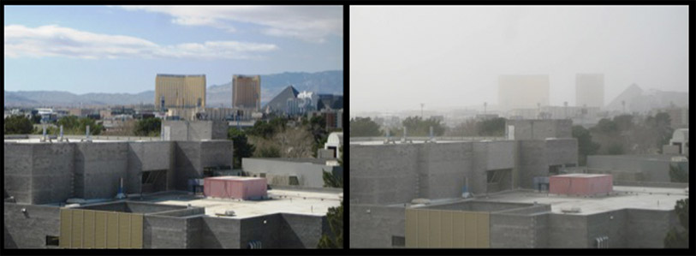

Some of the most dramatic and recent evidence of the health effects of amphibole asbestos (AA) comes from Libby, Montana, where extensive exposures to a mixture of fibrous amphiboles occurred due to decades of mining and community use of asbestos-contaminated vermiculite. Experience at the Libby MT Superfund Site has taught us that non-cancer pleural disease may be the most prevalent AA-related disease (ARD) [5, 7, 8, 19, 20], having potentially massive effects on public health in years to come due to disease latency. The pleural disease seen with Libby Amphibole asbestos (LAA) is associated with pain, progressive loss of lung function, and death [5, 21-23]. LA has also been linked to serum autoantibodies (AutoAb) [28, 31, 62], and an increased risk of systemic autoimmune disease [63], signifying an autoimmune outcome. Further, LA induces mesothelial cell AutoAb (MCAA) which induce collagen deposition by mesothelial cells in vitro [64] and are associated with radiographic changes in the pleura [62]. In mice, MCAA instilled into the peritoneal cavity can trigger collagen deposition in peritoneal tissue, suggesting that MCAA could contribute to pleural fibrosis [65]. Unlike LAA, chrysotile asbestos does not induce AutoAb in mice or humans [29, 66], and while MCAA occur with chrysotile (at significantly lower frequencies), they are not associated with pleural disease [29]. Therefore, the assessment of potential health outcomes cannot consider all asbestos types together, and must take into account subtleties of fiber mineralogy, chemistry and morphology. Several comparison studies have been undertaken in various models, but most often the studies are limited to carcinogenesis and pulmonary fibrosis (asbestosis) - and very often compare the two broad families of commercial asbestos, chrysotile versus amphibole, at occupational exposure levels [32, 33, 67-72]. Historically, hypotheses regarding pathogenicity have focused on length, surface area, or biopersistence [32-34], where long, thin biopersistent (amphibole) fibers receive most of the blame for health outcomes. However, due to striking differences even among amphiboles, some of these beliefs have been challenged [73, 74], and the relative pathogenicity determinants may be much more complex. Our approach is extremely significant in (a) its collaboration with nationally established experts in medical geology and mineralogy (Drs. Buck and Metcalf, UNLV) to ensure that rigor and interdisciplinary expertise are applied to the work, and (b) our previous work with the Libby Superfund Site for which extensive preliminary data exist [5, 19, 21, 23, 31, 36, 58, 75-77] and with whom we work closely.

During 2016, we conducted a pilot study in mice that compared LAA with a mineral fiber mixture with some chemical similarities to LAA, that we called Arizona Amphibole (AzAA). We used 1/20th of the dose previously used in our studies of LAA, in an attempt to model low environmental exposures. Amphibole fiber mixtures have been discovered within and near the Las Vegas metropolitan area of southern NV where the material exists in extensive desert recreational areas, residences, dirt roads, parking lots and school grounds, and in rock formations just across the state line in northwestern Arizona [1, 2]. Soils and rocks in this region are being disturbed by road construction and urban development, and fibers can become airborne through natural wind erosion [78], leading to many questions and concerns in these communities [79]. Preliminary data using *non-elutriated*, raw fibers indicates that the Arizona amphibole, is at least as toxic as LAA (Figure 2) especially at very low concentrations.

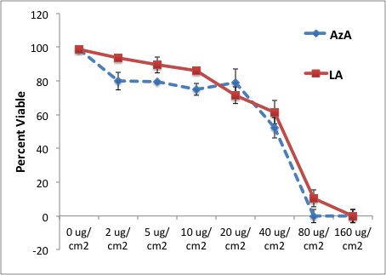

**Figure 2**. Arizona amphibole (AzA/AzAA) was compared with LA in terms of RAW264.7 macrophage cytotoxicity (left). Both mineral fibers produced nearly identical toxicity curves (by Cell Titer Blue assay, Promega), with AzA being more toxic at low dosages (p<0.05 by one-way ANOVA with post-hoc testing at 2, 5, and 10 ug/cm2). Data points indicate means, and error bars are SEM. N = 6 individual wells in each treatment group.

The AzAA fibers also induced ANA and lung collagen levels at or above those induced by LA using a very low dose of 3 µg/mouse by oropharygeal aspiration (Figure 3) (manuscript in preparation).

Recently, the Environmental Protection Agency (EPA) conducted a risk assessment specifically for LA based on a study that concluded that significant health effects were occurring at extremely low exposure levels [6]. LA is the first mineral fiber for which a toxicity value (Reference concentration, RfC) has been derived to help define a remediation target to reduce the risk of acquiring *non-malignant* respiratory disease. The RfCLA was released in December, 2014, at 0.00009 PCM f/cc (Phase Contrast Microscopy fibers/cubic centimeter) and finalized in 2015 [8]. The dramatic outcome of this fiber-specific health assessment, based on a specific non-cancer outcome (pleural fibrosis), emphasizes the need to evaluate health impacts based on mineral fiber composition from different sites. Also, mineral fibers are found in newly discovered locations, occurring in soils in many parts of the US and around the world, leading to human exposure from land development and use of the material in roads, parking lots, and recreational areas, as described above. Similar to the study used by the EPA, the Libby Epidemiology Research Program (LERP, ATSDR, TS000099-01) has shown that

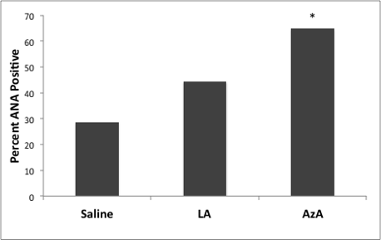 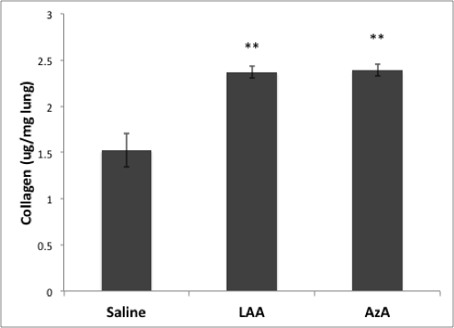

**Figure 3**: (Left): ANA testing was performed 7 months after exposure to only 3 µg/mouse of non-elutriated LA and AzA. Serum was diluted 1:80. By Fisher's Exact Test, only the results with AzA were statistically significant (P<0.05), suggesting that it requires a higher dose of LAA to get a significant ANA response at 7 months. (Right): Lung collagen measured by hydroxyproline assay (QuickZymeTotal Collagen Assay) was significantly elevated at 7 months with both LAA and AzA.

50% or more of people exposed environmentally to LAA suffer from pleural scarring, and that this scarring can dramatically impact pulmonary function, eventually leading to significant disability and death [5]. Thus, the public health impacts of on-going, current exposures, in addition to exposures over the last few decades, could be tremendous. Land use decisions in areas where AA fibers are discovered need to be based on strong data supporting (or not supporting) the application of the very low Libby RfC more broadly to other AA.

Finally, well-characterized AA standards are very much needed for future health studies. In this project, we will develop and characterize three new AA standards: Nevada AA (NvAA) [1, 3], Arizona AA (AzAA) [2, 3], and Minnesota (MnAA, same type of amphiboles involved in the Reserve Mining case [80]) which will be made available to other researchers for future experiments. Over 70 individual mineral species, classified by chemical composition, comprise the amphibole group. In this proposal and our published work [1, 2] we use the IMA1997 [81, 82] amphibole classification, which has been used in most Libby studies. Among the AA minerals that are known to be toxic, there is considerable compositional variability. The general amphibole formula is A0-1M42(M1-3)5T8O22(OH,F,Cl,O)2 (Table 1); the IMA1997 [81] classification breaks amphiboles into four broad groups based largely on M4 cation site occupancy, the Calcic Group, the Sodic-Calcic Group, the Sodic Group, and the Fe-Mg Group (Table 1). Within each of these groups further subdivision is based in part on the Mg/(Fe2+ + Mg) ratio (Mg and Fe2+ on M1-M3 cation sites, Table 1). Nevada actinolite belongs to the Calcic Group (M4 nearly filled with Ca); actinolite is closely related to tremolite but with slightly more Fe2+. Libby amphibole (LA) is predominantly winchite, part of the Sodic-Calcic Group (Table 1) with Na1+ substituting for Ca2+ on M4, and Fe3+ substituting for Mg­2+ or Fe2+ on M1-M3. The AzAA overlaps the Sodic-Calcic (winchite) and Sodic Groups (magnesioriebeckite) and is more Na-rich and Fe3+-rich than LA; increasing Na in these amphiboles is positively correlated with increasing Fe3+ 2. Grunerite, found in taconite iron ores in Minnesota and Wisconsin [83, 84], is in the Fe-Mg Group (Fe-Mg in M4 site rather that Ca or Na) with low Mg/(Fe2+ + Mg), as such MNAA composition is far removed from LA, NvAA and AzAA. These four amphiboles taken together cover a significant portion of the compositional range of known amphibole asbestos.

Table 1: Fibrous Amphibole mineral names and general chemical formulas.

|  |  |  |  |
| --- | --- | --- | --- |
| **Regulated and Non-Regulated Fibrous Amphiboles** | | | |
| **Mineral**  **Name** | **End Member Formula**  **A0-1M42(M1-35)T8O22(OH)2** | **Amphibole**  **Group** | **Regulated** |
| **Grunerite** | Fe2+2Fe2+5Si8O22(OH)2 | Fe-Mg | Yes |
| **Anthophyllite** | Mg2Mg5Si8O22(OH)2 | Fe-Mg | Yes |
| **Tremolite** | Ca2Mg5Si8O22(OH)2 | Ca | Yes |
| **Actinolite (Mg>Fe2+)** | Ca2(MgFe2+)5Si8O22(OH)2 | Ca | Yes |
| **Winchite** | (NaCa)(Mg4Fe3+)Si8O22(OH)2 | Na-Ca | No |
| **Richterite** | Na(NaCa)Mg5Si8O22(OH)2 | Na-Ca | No |
| **Riebeckite** | Na2(Fe2+3Fe3+2)Si8O22(OH)2 | Na | Yes |
| **Magnesioriebeckite** | Na2(Mg3Fe3+2)Si8O22(OH)2 | Na | No |

Our preliminary data and references cited provide rigorous support for this project. We are addressing key research points that have been emphasized in critical reviews of the literature [18, 38, 85], and we are engaging advice and work by EPA and NIEHS intramural researchers [4, 69, 86].

**(b) Innovation**

This project developed immediately after several paradigm-changing discoveries. First, we learned that LA causes an unusual and devastating lamellar pleural thickening that over time progresses to severe pulmonary dysfunction and death [5]. This occurs in over 50% of those exposed to LA even at low exposure levels (1 manuscript submitted, and [87]). Our approach includes examination of non-cancer outcomes that are highly relevant to environmental amphiboles. Second, this pleural thickening can be replicated in mice and shown to be associated with the presence of autoantibodies. Using a multiphoton confocal microscope, we are able to detect and quantify collagen deposition on the visceral and parietal pleural surface using a published protocol [88]. For this technique, lungs can be fixed, but neither sectioning nor staining is required since the collagen is detected at various depths in the tissue simply due to its second harmonic generation (SHG) properties, and imaged following 2-Photon Excited Fluorescence (2PEF) (Figure 4).

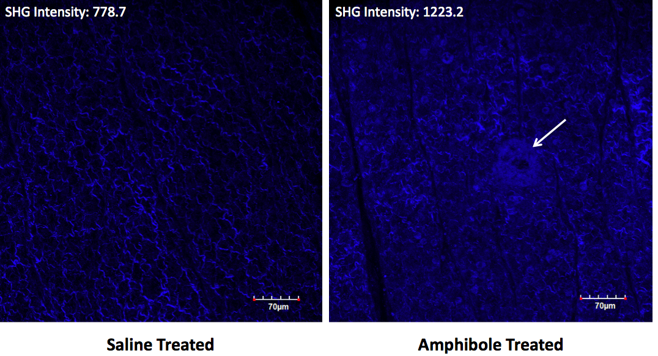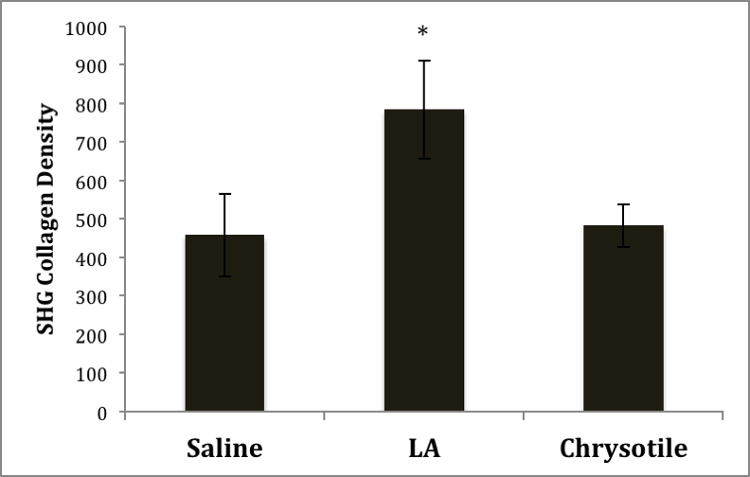

**Figure 4.** Images of mouse visceral pleura 7 months after intratracheal instillation of saline (left) or LA (right), using 2-photon microscopy. Collagen is detected using second harmonic generation (SHG), with density/intensity shown, indicating diffuse pleural collagen in the LA-exposed mouse (blue), but not the saline-treated mouse. Arrow = pleural plaque in addition to diffuse collagen deposition. Graph shows mean collagen density, error bar = SEM, n=4, * = p< 0.05. Chrysotile = commercial serpentine asbestos, which does not induce autoantibodies in mice [9]. Treatments were equal mass of fibers.

Third, we have recently discovered a novel biomarker that may predict pathogenicity in exposed humans. In both humans and mice, mesothelial cell autoantibodies (MCAA) have been associated with LA exposure [62, 65, 66], and these autoantibodies drive collagen deposition in vitro [64, 66]. Further, LA-induced MCAA are associated with pleural disease in humans [62], and can induce fibrosis in mice [65]. Further, we have identified specific transcription factors activated by MCAA; inhibition of those TFs significantly reduces collagen deposition by cultured mesothelial cells treated with MCAA [89].The fact that serum cleared of all IgG is unable to cause these effects demonstrates that it is an antibody-induced mechanism [64, 65, 89, 90].

Fourth, recently we discovered, using a proteomics approach, that one of the antigen targets for the MCAA is cell surface plasminogen (PLG) [90], which is known to play a role in limiting pulmonary fibrosis [91-93]. Based on this published literature, we hypothesized that the anti-PLG antibodies were blocking the protective (anti-fibrotic) effect of plasminogen, thereby leading to increased collagen deposition. Indeed, removal of the anti-PLG from MCAA-containing serum completely prevented collagen deposition [90], and addition of a commercial blocking antibody to PLG (R&D, Clone 270409, antihuman PLG) also increased collagen deposition by cultured mesothelial cells. These data suggest that MCAA, and especially anti-PLG, may be biomarkers of pathogenicity.

Historically, hypotheses regarding pathogenicity have focused on length, surface area, or biopersistence [32-34]. However, some of these ideas have been challenged [73, 74], and the relative toxicity determinants may prove to be more complex. Our study using the Arizona AA provided evidence that the very tiny fibers (<5 microns long) may be highly potent in the immune effects. On a flow cytometer, side scatter gives a value that represents particle uptake by macrophages [94]. Macrophages are generally on able to phagocytose particles less than their radius, so less than 10 microns long. In our preparation of AzA, we found significantly elevated side scatter compared to the preparation of LA, indicating a high frequency of very short fibers. Because of the chemical similarity between the two fiber mixtures, we hypothesize that the tiny fibers may be key to immune/autoimmune outcomes that also indicated a greater pathogenicity for AzA (Figure 3).

Further evidence of the importance of very small fibers comes from the research in nanotubes, for which the range in width and length tend to be much smaller than is even counted as asbestos. Health impacts from nanowires and nanotubes are comparable to asbestos even when the fibers are less than 10 microns in length

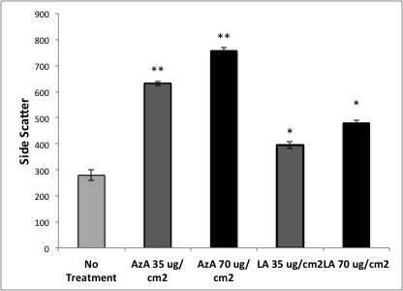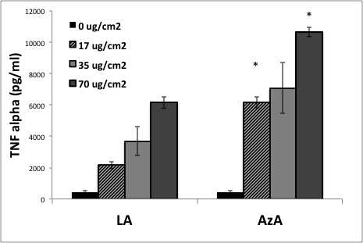

**Figure 5**: RAW264.7 macrophages were cultured with different concentrations of LA and AzA for 24 hr. **Left:** Analysis by flow cytometry shows high side scatter with AzA compared to LA, * = p<0.05 compared to No Treatment, ** = p<0.05 compared to LA at same concentration. **Right**: TNF alpha ELISA assay of culture supernatants shows significantly more TNF alpha produced by AzA, * = p<0.05, compared to LA at same concentrations. N=4 individual wells for each treatment.

Due to our extensive characterization of our animal model in terms of the unique outcomes of LA exposure, we are optimally poised to significantly advance the field by using extensively characterized samples of Nevada AA (NvAA), Arizona AA (AzAA), and Minnesota AA (MnAA) fibers to determine the key pathogenicity factors. In the Nevada/Arizona region, the AA has very distinct chemical compositions with sodium-rich AA in sourced in northwestern Arizona [3] and calcium-rich AA sourced in southern Nevada [2] (Figure 6). Erosion and deposition by wind has distributed the AA to far outlying areas and increases the potential for human exposure (Figure 7). There is also evidence of different size distributions of the fibers when released from the rock and soil (add data or observations?)

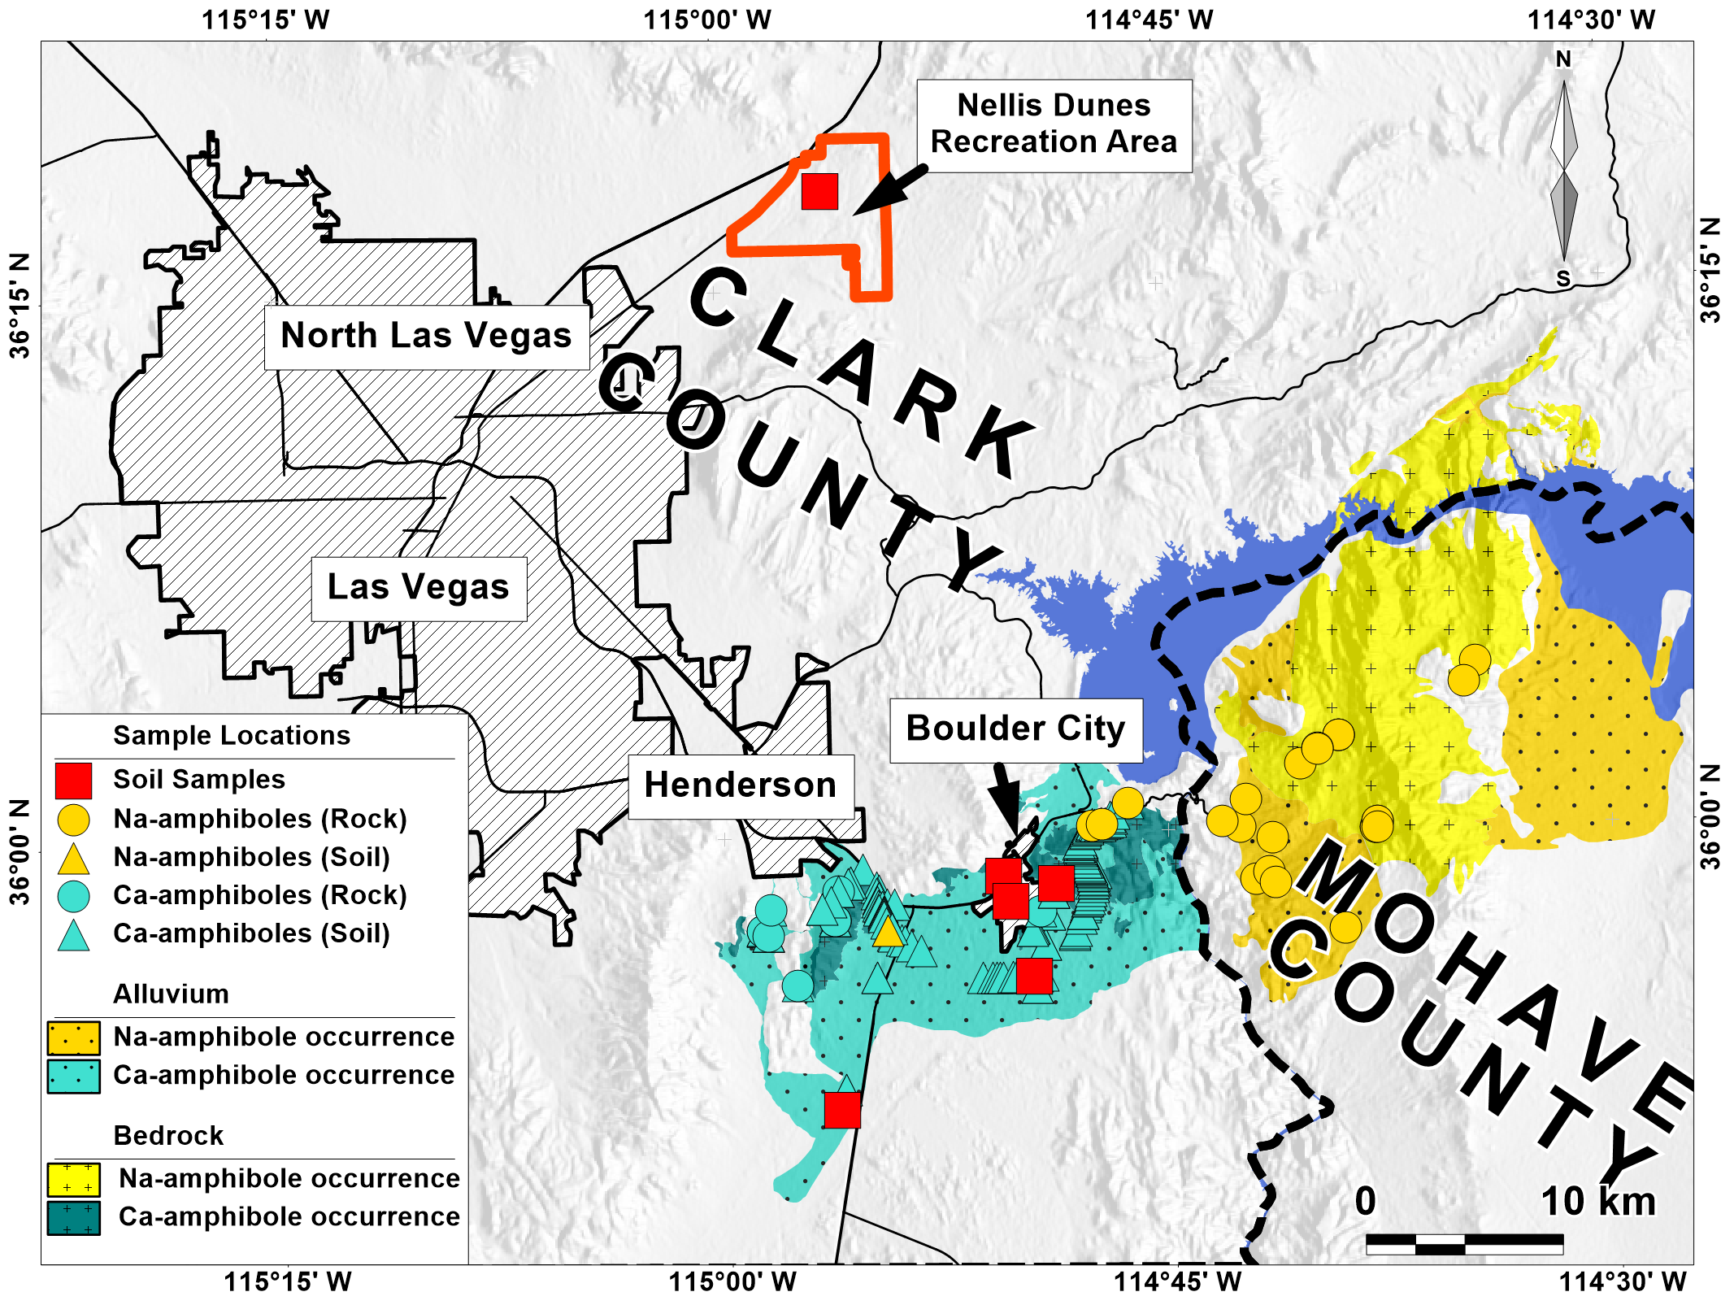

**Figure 6**. Known and predicted AA near Las Vegas NV. Calcium-rich AA is the dominant fibrous amphibole in Nevada (teal color), whereas sodium-rich AA dominates in northwestern Arizona (yellow). Wind erosion and deposition mixes these different AA minerals in surrounding soils, including at least 37 km north of source areas (Nellis Dunes Recreation Area; see also Figure 7).

**Figure 7**. Map of southern Nevada/ northwestern Arizona showing known occurrences of AA (red dots), and predicted occurrences based on geological processes. Known sites outside of the predicted areas are soils where wind deposition has transported the AA to outlying areas.

**(c) Approach**

General Materials & Methods

C57BL/6 mice will be purchased from Jackson Laboratories, Bar Harbor, Maine, and housed in Specific Pathogen Free (SPF) conditions in the MSU animal facility, with free access to food and water. Because stress can affect immune function, we will minimize stress on the animals by providing materials for burrowing and hiding (but using low-dust bedding), limiting animal number per cage, separating any animals experiencing aggression, and avoiding vibrations and loud noises. All mouse protocols will be approved by the MSU IACUC, and a general protocol is already in place, requiring only an update of animal numbers. Ten mice of mixed sex will be used for each treatment group: No treatment (saline), LAA, NvAA, AzAA, and MnAA . Power analyses and previous work with LAA have established that significant differences can be seen with as few as 4-6 mice for most of the assays, so using 10/group adds to our power.

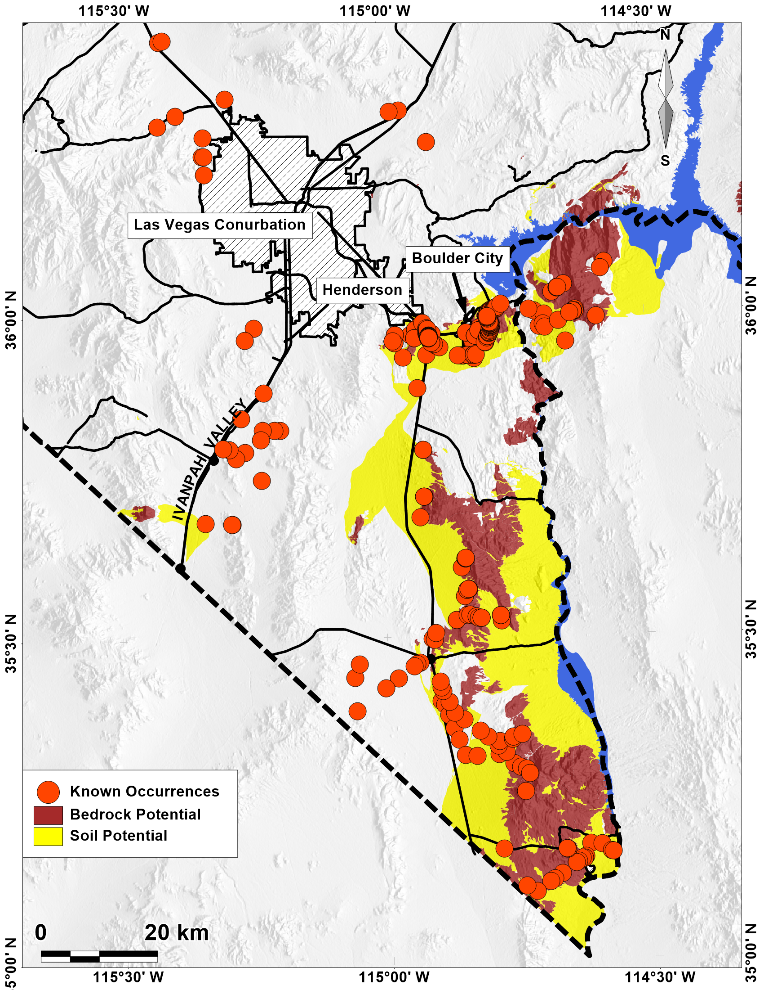

Collection and Analysis of Fibrous Amphibole Samples

Libby Amphibole (LA 2007) will be provided by the USGS (Dr. Stephen Wilson), and NvAA, AzAA, and MnAA will be collected and provided by Drs. Buck & Metcalf (UNLV). Drs. Metcalf and Buck have samples of NvAA, and AzAA, but will collect additional materials (more volume to process) as part of this project. MnAA will be collected from field sites on public lands in Minnesota and/or Wisconsin by Dr. Metcalf. In order to obtain relatively pure samples of AA, the fibrous amphiboles (NvAA, AzAA, and MnAA) will be extracted from the exposed AA veins on broken rock sample surfaces using hand tools (dental tools and small electric grinders) under a negative pressure hood. The AA separates we have produced to date using this extraction technique are predominately AA, but do include minor amounts of other minerals (mostly feldspar). It is not possible to collect enough fibers by air sampling, especially that are this free of other particulate contamination, using any kind of air sampling. Sampling from soil and rock is standard technique for mineral fibers, and was used to collect the only LA samples currently available for use in research. (Need more here?)

**Rigor and Transparency**: We have been successful in publishing our findings in the past, and as years go by, the findings continue to support our earlier data. In order to continue to foster rigor and transparency in our work, we are using advice and work by intramural researchers at EPA and NIEHS, and we will work closely with them to seek their guidance on experimental design and data interpretation. For published works, we will include details of the fiber characterization, animal studies and analyses either in the publication itself or in available data sharing archive sites.

***Aim 1****: Develop a detailed comparison of fiber morphology, chemistry and morphology of the four samples (LAA, NvAA, AzAA, MnAA) with particular attention to the frequency of very small (how small?) fibers.*

*a) Perform water elutriation of all raw samples to create respirable fractions.*

*b) Determine median fiber sizes, plus mineralogy and chemistry of the samples.*

All fiber separates discussed above will be elutriated at UNLV to the respirable fiber fraction using the method developed by Dr. Pfau and collaborators, and currently in use by intramural EPA researchers for in vitro and in vivo research [86, 95]. The elutriation will further concentrate AA and limit contamination by larger accessory minerals (e.g. feldspar). All asbestos samples will be characterized by our UNLV team before and after elutriation. The elutriated, respirable fractions will be fully characterized at UNLV by the following methods: Fiber morphology will be measured using a JSM7500F Field Emission Scanning Electron Microscope (FE-SEM) with Energy Dispersive Spectrometry (EDS) at the Electron Microanalyses and Imaging Laboratory (EMIL) at UNLV. For each sample, a minimum of 1000 particles will be characterized and will include particle width, length, and aspect ratio [96]. Each particle will also be characterized using EDS chemical analysis, and these data will be used to characterize particle mineralogy of the elutriated samples. The surface area of each sample of respirable fibers will be measured using a Quantachrome Nova 1000 system at UNLV.

State of the art, highly precise measurements of the chemical composition of the amphibole minerals require an Electron Probe MicroAnalizer (EPMA) using Wave Length Spectrometry (WDS). EMPA-WDS data require a polished thin-section for optimal results. Previous EMPA data [1, 2, 97] have demonstrated that AA compositions can vary significantly in samples from a single sampling site. To insure that we understand the compositional variations in each of our samples, we will collect mineral compositional data at multiple steps along the separation-elutriation process. Compositional variations in the starting materials (NvAA, AzAA, and MnAA rock samples) will be evaluated using EMPA-WDS on thin-sections (multiple sections per sample, 200 points per section). There is potential that the elutriation process will select for smaller fibers that that are biased towards one part of the compositional range (for example smaller fibers may be more Na-rich). As such we will also collect EMPA-WDS composition a data on polished mounts of elutriated fibers for comparison. Finally, FE-SEM-EDS data on individual fibers is semi-quantitative measurement; we will use the EMPA-WDS data set to aid us in evaluating the FE-SEM-EDS data discussed in the previous paragraph. All EMPA-WDS work will be conducted at UNLV using a JEOL 8900 EMPA. At the end of this study we expect to have created well-characterized reference standards for these AA samples that can be utilized by future scientists in their bio-medical research.

***Aim 2****: Use equal-mass OR equal-surface area (SA)?? in vitro exposures to assess the impact of relative median surface area (and therefore fiber size) on toxicity and activation of macrophages and splenocytes from mice.*

*a) Measure T helper cytokine subsets in post-exposure culture fluid from splenocytes.*

*b) Measure macrophage cell toxicity, oxidative stress and DNA damage*

Dosage and Toxicity: The in vitro experiments will test several concentrations (starting near the predicted number of fibers calculated from the Libby Amphibole Reference Concentration (RfCLA), corrected for body size and by our knowledge of mouse physiology (breath volume and rate), and that a mouse lung contains around 1 million alveolar macrophages. In short-term (24 hr) culture, 1 million macrophages in a 2 cm2 well, respond to concentrations under 25 µg per well, which is a very low concentration compared to other previous studies. For longer term cultures, we have seen effects as low as 5 µg well. We have not tested even lower concentrations for longer periods of time, so we will try several different configurations of the experiment to determine the Lowest Observed Adverse Effects Level (LOAEL). Because splenocytes do not last long in culture, so we will use the RAW264.7 macrophage cell line (as for our preliminary data) for toxicity assays.

For in vitro outcomes, we will harvest spleens from untreated mice, collect splenocytes by mincing the spleens and then lysing the red blood cells, using previously published protocols [98, 99]. The splenocytes will be cultured in 24-well plates in which they will be treated with different concentrations of the four types of AA, to compare against untreated cells. The cells will be evaluated for cytotoxicity by Cell Titer Blue, for overall toxicity; or Live/Dead Fixable Stain (BD Biosciences) by flow cytometry to detect toxicity in particular cell types), and culture supernatants will be assayed for Th1/Th2/Th17 cytokines using the multiplex bead array, as described [98, 99]. These data will address the comparative toxicity and immunostimulatory effects of the different fibers, and will also inform the in vivo experiments regarding expected differences between the different fibers in the mice if we see differences in culture. We will also perform basic toxicity assays using RAW264.7 cells (ATCC) to assess cytotoxicity (dose responsive) by Cell Titer Blue (Promega's MTS assay) and inflammatory cytokines (TNF alpha, IL-6) by ELISA (BD Biosciences). The purpose of these experiments is to assess relative toxicity and inflammatory potential, as related to the fibers' relative effects on autoimmune outcomes.

Dr. Keil and Dr. Pfau both have experience in evaluating oxidative damage by dust particles [100-103]. These in vitro studies have proven to be excellent for training students in the laboratory. In order to assess carcinogenic potential, the following testing will be done to assess oxidative stress and DNA damage in cultured mouse macrophages (RAW264.5) and human mesothelial cells (Met5A)(both from American Type Culture Collection):

a) Anti-oxidant Status Assay (Cayman Chemical): A biochemical reaction assay in a microtiter format

b) Superoxide Dismutase (SOD) Assay (Cayman Chemical): Biochemical assay

c) Expression of Xct on macrophages as described above (antibodies from Santa Cruz).

d) Gamma (γ)-H2AX phosphorylation (ThermoFisher) assay: Flow cytometry detection of dsDNA breaks

The Anti-oxidant Status Assay measures the ability of the cells to inhibit the oxidation of ABTS® to a detectable metabolite, metmyoglobin. When the antioxidant status of the cell is reduced through asbestos-induced oxidative stress, metmyoglobin levels will be higher. This is a very general measure of anti-oxidant status. The capacity of the antioxidants in the sample to prevent ABTS oxidation is compared with that of Trolox, a water-soluble tocopherol analogue, and is quantified as molar Trolox equivalents. The SOD assay measures this specific enzyme that is critical in detoxifying reactive oxygen species, and which has been shown to be suppressed by LA in vitro [100]. System xCT is an antioxidant system that uses an amino acid exchanger (the Xct transmembrane protein) to increase cysteine and glutathione anti-oxidant levels in the cell [104, 105], and it has been shown to be upregulated by amphibole asbestos, but not silica [106, 107].

Double-strand breaks in DNA result in the phosphorylation of histone H2A variant H2AX, and this is considered to be a reliable and sensitive marker of DNA damage. A live/dead dye is included in the kit (ThermoFisher Scientific) to allow the measure of dsDNA breaks and resulting cytotoxicity at the same time. Both are fluorescent, allowing cell by cell quantitative detection by flow cytometry. This technique has been used to demonstrate dsDNA damage by asbestos, and to quantify relative genotoxicity of different forms of asbestos [108], thus impacting their ability to cause cancer.

***Aim 3****: Use equal-surface area exposures in mice to assess health outcomes*

*a) Pulmonary outcomes (interstitial and pleural fibrosis)*

*b) Autoimmune outcomes (autoantibodies and white blood cell subsets)*

Dosage and Tissue collection

Dosages will be on an equal mass basis (OR EQUAL SA?), based on our preliminary data from a pilot grant: mice were treated with non-elutriated LA and AzAA at the dose we have used for publications on LA in mice (60 µg/mouse in two 30 µg doses), plus a very low concentration at 1/20th (3 µg/mouse in two 1.5 µg doses). Because we have now seen preliminary effects at that low dose (Figure 3), we will use the low dose or even lower, in order to be in the range of relevant environmental exposure levels, scaled to mice. Outcomes will be analyzed taking into account relative length, width, aspect ratio, surface area, mineralogy, and chemistry working with our UNLV collaborators. Instillations will be oropharyngeal (o.p.) to best model inhalation, using suspensions sonicated in sterile saline, and mice are given 20 µl of either sterile saline only or saline with fibers. Although inhalation chambers may be considered a better way to model human exposure, it has actually been shown to be expensive, hazardous, and difficult to standardize quality control [109]. Intratracheal and orpharyngeal aspiration have both been shown to be effective and well-characterized models for drug and particle exposures as long as their limitations are noted, with o.p. being somewhat more effective at recapitulating outcomes seen in humans [109-113]. All other mouse procedures will be as previously described [30, 114].

Following the designated treatment period (7 months based on previous studies, but before mortality occurs due to developing disease), overall toxicity will be assessed by weight change, and urine samples will be taken to assess kidney function using albumin strips. Mice will then be euthanized by CO2 asphyxiation, and blood will be immediately collected by cardiac puncture, clotted at room temperature, and then centrifuged to collect the serum. Pleural wash is performed by injecting 0.5 ml of sterile saline into the pleural space through the diaphragm, then withdrawing the fluid [114]. Cells will be centrifuged and stained as described below for spleens, but with a specific focus on B cell subsets due to our previous work showing activation of B1a B cells by LA [114]. B1a B cells have been implicated in autoimmunity [115, 116]. Lungs will be carefully dissected out and, from each mouse, one lung will be fixed flattened in Histochoice fixative for 2-photon microscopy, and the other fixed slightly inflated with Histochoice for histology and collagen assay. The spleens will also be harvested, processed to cell suspension, and stained for flow cytometry to detect T cell and B cell subsets, macrophages/dendritic cells, and Natural Killer (NK) cells (all antibodies are readily available from BD Biosciences, see below). Parietal pleura (diaphragms), peritoneal walls and kidneys will be collected & fixed to assess the extent of serous fibrosis, or lupus-like immune complex deposition in the kidney.

Pulmonary Outcomes:

The EPA RfC developed for LA showed that pleural fibrosis was a more sensitive indicator for risk than cancer, leading to a lower RfC [8]. We therefore expect that pleural fibrosis may be the most sensitive indicator of pathogenicity. We will measure this using multiphoton confocal microscopy, measuring 2-photon excited fluorescence (2PEF) as described above for Figure 4. The fixed, flattened lungs will be analyzed by 2-PEF for collagen density of the visceral pleura (Letter of support from Idaho State University). For 2PEF, left lungs will be secured on wax with small pins in a dish containing water, and placed in the microscope. The depth of the collagen is defined by visualizing focal planes at the top and bottom of the 2PEF detection. Eight to ten random fields (640 x 640 µm) are scanned under 40x objective using a Z-stack, and the result can be quantified as “density” of collagen (Figure 2 and 5). For parietal pleural fibrosis and interstitial fibrosis, we will use the QuickZyme® Total Collagen Assay on diaphragms and right lungs, respectively. We have demonstrated our ability to use this assay to detect differences in collagen content in tissues (Figure 3).

Autoimmune Outcomes

a) **ANA** are measured by indirect immunofluorescence (IIF) using standard ANA slides from ImmunoConcepts, but modified for use with mouse serum with FITC-conjugated anti-mouse IgG (Pierce Antibodies) as the secondary antibody. We use IIF due to its continued support as the main screening assay for ANA [117], and the ease of converting it for use with mouse serum [9]. AFA and MCAA are measured by cell based ELISA [64, 66]. TH17 cytokines will be measured in the serum using a Cytokine Bead Array for mouse TH1/TH2/TH17 cytokines as we have done previously [9].

b) Antibodies to detect **the immune cell subsets** will be purchased from BD Biosciences. Staining will be done as previously described [30, 114, 118], and analysis will be on a FACS Calibur flow cytometer in the FACS Core Laboratory at MSU. Briefly, the staining and analyses are as follows:

Pelleted cells will be washed in PBS then suspended in 100 µl of PBS with 3% BSA for staining, using the following combination of antibodies (all from BD Biosciences, San Jose, CA): CD19-PE, IgM-PerCP-Cy5.5, CD5-APC. Functionally-polarized T regulatory cells (T reg) versus TH17 T cells will be detected using the BD Biosciences Mouse TH17/Treg Phenotyping kit, which consists of antibodies to CD4, IL17A and Foxp3 and all reagents needed for intracellular and surface staining. Cell populations will be analyzed using the FACS Calibur flow cytometer in the Core Facility at MSU as follows, gating out cell debris, red blood cells, and doublets using side x forward scatter and live/dead staining kits (BD Biosciences):

Macrophages, Granulocytes and lymphocytes by forward scatter x side scatter; B cells = CD19 positive; T cells = CD5 positive; B1a B cells= CD5 and IgM positive (21), Treg = CD4 positive/foxP3 positive, TH17 T cells = CD4 positive/IL17 positive. All data will be collected as percent of the parent population, both percent of all peritoneal cells, and percent of lymphocytes. We will also analyze specific granulocyte subsets (neutrophils, eosinophils, basophils), which is easiest (especially for small samples from mouse pleura) using a Cytospin cell analyzer, which will be purchased for the purpose of this Aim. We will also use this instrument for visualizing the cells from the pleural cavity in terms of any fibers taken up by macrophages, as evidence of the fibers arriving in the pleural space, as a descriptive but informative outcome.

c) **Mesothelial Cell Autoantibodies (MCAA)** are measured in a cell-based ELISA, using cultured primary mouse mesothelial cells. These cells are collected from harvest mouse peritoneal wall tissue using a method modified from [119], and as reported in our recent publication [65]. Cells are determined to be primary mesothelial cells if they show mesothelial cell morphology and lack both fibroblast and macrophage specific markers (anti-mouse Pan-Reticular Fibroblast Marker, Cedarlane, Hornby, Ontario; anti-CD90.2 (Thy-1), from eBioscience (San Diego, CA)).

A cell-based ELISA for MCAA is performed as previously described [64] to test for the binding of serum antibodies to mesothelial cells. Briefly, mouse primary mesothelial cells are seeded at confluency on 96 well plates, attached overnight and fixed in 1% paraformaldehyde. Following washing with PBS-Tween (0.05%), cells are blocked with 5% non-fat dry milk/PBS and then exposed to individual mouse sera from each of the treatment groups diluted in 3% BSA/PBS (1:100). Following a 2-h incubation with serum, cells are washed, secondary antibody HRP-conjugated goat anti-mouse IgG (Invitrogen) is applied at a dilution of 1:1000 in 3% BSA/PBS and incubated for 1 h. Excess antibody is removed and plates developed using TMB substrate (Thermo Scientific) followed by 50 µl 1M HCl. Plates are analyzed at 450 nm on a microtiter plate reader. Correction for non-specific secondary antibody binding is performed on a plate-to-plate basis by subtracting the mean optical density (OD) for the secondary antibody-only control wells from the mean OD of each sample. Samples are determined to be MCAA-positive (MCAA+) if the corrected OD is at least three standard deviations above the mean OD for control (normal, untreated) mouse serum or serum cleared of IgG using Protein G beads according to the manufacturer's protocol.

d) **Antibodies to plasminogen,** as a pathogenicity marker, will be detected using a standard ELISA. Commercially-available mouse plasminogen (purified mouse PLG, Innovative Research, Inc., Novi MI), will be coated onto high binding ELISA plates using carbonate buffer, and then diluted serum (1:100 in PBS) will be added to wells to determine whether there are antibodies in the serum that bind to plasminogen [90]. The plates are washed and then secondary antibodies conjugated to horseradish peroxidase (HRP) are added (pan anti-mouse IgG-HRP), following by washing, and then development with ELISA TMB substrate

**Anticipated Outcomes /Data Analysis/Alternative Strategies**

For all data analysis, we will use the expertise of the Montana State University Statistical Consulting and Research Services, directed by Dr. Lillian Lin (See letter of support). They have assisted with the planning of this study and the analytical approach.

Our hypothesis is that shorter fibers will prove to be more immunostimulatory, even though most data has suggested that longer fibers are more carcinogenic and fibrogenic [69]. The general consensus regarding the impact of fiber length has met challenges [73], and therefore requires this kind of rigorous scrutiny. Deleterious effects on the immune system can impact all of the ultimate disease outcomes of asbestos, including cancer, fibrosis, and autoimmunity.

Aim 1: Fiber sample analyses:Outcomes here will be population statistics of defined representative samples from each fiber type, to include the size and chemical variables described above. A representative table is shown below (Table 2). ROD and BRENDA will complete this section.

Aim 2: In vitro Outcomes:In vitro experiments will provide continuous data as cytokine measurements, given in micrograms per ml (µg/ml) based on standard curves provided with the kits, or cell numbers as provided by counts which we can get from flow cytometry and cytospin counts by multiplying the percent of each specific cell type by the total number of cells that serves as the denominator for the subset (eg, all cells in the sample).

Measurement of oxidative stress outcomes and DNA damage provide continuous data in absorbance or fluorescence values. These data will be analyzed…

Aim 3a: Pulmonary Outcomes: Key quantitative data in this sub-aim will be derived using the QuickZyme Total Collagen Assay and 2-PEF, as we have previously described [65]. Both types of data can be considered "continuous" or numerical data, to be analyzed using a t-test or One-Way ANOVA to compare the mean values from each group of mice. We anticipate that all AA samples will increase collagen above saline control. We will then separately compare collagen values for different independent variables (e.g., dose, avg length, surface area, aspect ratio, or ion quantity, as calculated by Dr. Metcalf). Data analysis….

We will test the hypothesis that, although there will be more pleural collagen in mice exposed to fibers compared to saline, there will be differences based on the frequency of small/short fibers in the asbestos sample. The data will be continuous, since 2PEF from multi-photon analysis is a density measurement and the amount of collagen using the biochemical assay is given in micrograms, as calculated against a standard curve provided with the kit. We are confident in our ability to detect differences in pleural collagen, and use the 2 assays to ensure rigor in the interpretation. We are exploring direct injection of AA into the pleural cavity, which would likely ensure more profound effects if we can master the technique, but would be harder to justify as relevant to human exposures. We and others have used the peritoneal cavity as a surrogate for the pleura [65, 120], and we can consider that alternative as well.

**Aim 3b: Autoimmune Outcomes:** ANA data are categorical, either as positive/negative or as titered values that come from the serum dilution at which the test becomes negative, starting at 80 to represent the 1:80 serum dilution, then going to 160, 320, and up to 2560. All of these data will also be compared against fiber type as above (details on analysis), and then use XXXXX for analyses of effects of each of the parameters in the fiber characterization data from Drs Buck and Metcalf.

Antibody binding in the cell-based MCAA ELISA or other specific antigen ELISAs provides continuous (absorbance) values, as well as positive/negative categorical data.

These data will help us answer some critical questions regarding mode of action (MOA). Because we have evidence that these specific antibodies contribute to the fibrotic disease from LAA, we want to know whether the other fiber types induce these pro-fibrotic autoantibodies in order to help us predict whether the health outcomes in humans might be similar to that of LAA. Our study will determine whether different AA also impact this adjuvant effect, and because cytokine profiles are profoundly impacted by redox status [106, 121, 122], the oxidative stress assays will provide key data on MOA.

In addition, we will have data regarding the carcinogenic potential of the fibers, based on DNA damage relative to a known inducer of double-strand DNA breaks. These data will be continuous on that relative scale provided with the kit. (Again, data analysis will look at a) difference between fibers, and b) impact of fiber analysis data on this outcome..)

**OVERALL INTERPRETATION AND IMPACT**

The health impacts of asbestos exposure are complex, leading to this study of what we feel are the most impactful and sensitive measures based on our experience with Libby Amphibole. We believe that this study has the critical strength of very careful fiber analysis using the best-known techniques to evaluate fiber population sizes. It also has the strength of using both in vitro and in vivo models to assess relative pathogenicity of the fiber samples, all in an environment where different factors such as mineralogy, mean fiber size, and fiber size variability in the samples can be evaluated for their impact on ultimate outcomes. Further, we have the strength of excellent data analysis and interpretation by the professional team and MSU. Lastly, we have the strength of the expertise of well-established asbestos researchers with a great deal of experience working on these issues and in working as a multi-disciplinary team. We believe that the overall interpretation of these data will powerfully advance the field in the understanding of the relative pathogenicity of mineral fibers, which is critical in the current state of widespread environmental asbestos exposure. This study will be valuable to any agencies involved in screening of asbestos-exposure outcomes (CDC/ATSDR), and those involved in regulating asbestos exposure standards and predicting health outcomes of exposures to different fiber types (EPA, NIOSH, local/state public health agencies).

**Timeline**

|  |  |  |  |  |  |
| --- | --- | --- | --- | --- | --- |
|  | **Year 1** | **Year 2** | **Year 3** | **Year 4** | **Year 5** |
| **Aim 1** |  |  |  |  |  |
| MSU |  |  |  |  |  |
| UNLV | Fiber collection and elutriation | Fiber characterization | Continue Fe-SEM, Surface, morphology | Finish characterization,  Data compilation | Manuscript preparation |
| Data Sharing |  | Prelim Data-Fiber summaries, paper | Data exchange | Feedback and interpretation | Final reports + presentations |
| **Aim 2** |  |  |  |  |  |
| MSU | Tox/dose studies, in vitro | Analyze, repeat tox/dose studies | Cancer studies  In vitro | Data analysis:  Cancer outcomes | Manuscript preparation |
| UNLV | Confer on fiber data with MSU | Provide fiber samples to MSU |  |  |  |
| Data Sharing |  | Prelim Data-in vitro findings | Data exchange | Feedback and interpretation | Final reports + presentations |
| **Aim 3** |  |  |  |  |  |
| MSU | Purchase mice Start colony | Mouse exposures | Assay mouse samples | Data analysis:  Biomarkers | Manuscript preparation |
| UNLV | Confer on dosing strategies | Provide fiber samples |  |  |  |
| Data Sharing |  | Tox and redox studies shared | Combine data interpretations | Continue data exchange | Plans for new grant applications |

**REFERENCES**

1. Buck, B.J., D. Goossens, R.V. Metcalf, B. McLaurin, M. Ren, and F. Freudenberger, *Naturally Occurring Asbestos: Potential for Human Exposure, Southern Nevada, USA.* Soil Sci. Soc. Am. J., 2013. **77**: p. 2192-2204.

2. Metcalf, R.V. and B.J. Buck, *Genesis and health risk implications of an unusual occurrence of fibrous NaFe3+-amphibole.* Geology, 2015. **43**(1): p. 63-66.

3. Baumann, F., B.J. Buck, R.V. Metcalf, B.T. McLaurin, D.J. Merkler, and M. Carbone, *The Presence of Asbestos in the Natural Environment is Likely Related to Mesothelioma in Young Individuals and Women from Southern Nevada.* J Thorac Oncol, 2015. **10**(5): p. 731-7.

4. Benson, R., D. Berry, J. Lockey, W. Brattin, T. Hilbert, and G. LeMasters, *Exposure-response modeling of non-cancer effects in humans exposed to Libby Amphibole Asbestos; update.* Regul Toxicol Pharmacol, 2015. **73**(3): p. 780-9.

5. Black, B., J. Szeinuk, A.C. Whitehouse, S.M. Levin, C.I. Henschke, D.F. Yankelevitz, and R.M. Flores, *Rapid progression of pleural disease due to exposure to Libby amphibole: "Not your grandfather's asbestos related disease".* Am J Ind Med, 2014. **57**(11): p. 1197-206.

6. Lockey, J.E., K. Dunning, T.J. Hilbert, E. Borton, L. Levin, C.H. Rice, R.T. McKay, R. Shipley, C.A. Meyer, C. Perme, and G.K. LeMasters, *HRCT/CT and associated spirometric effects of low Libby amphibole asbestos exposure.* J Occup Environ Med, 2015. **57**(1): p. 6-13.

7. Rohs, A.M., J.E. Lockey, K.K. Dunning, R. Shukla, H. Fan, T. Hilbert, E. Borton, J. Wiot, C. Meyer, R.T. Shipley, G.K. Lemasters, and V. Kapil, *Low-level fiber-induced radiographic changes caused by Libby vermiculite: a 25-year follow-up study.* Am J Respir Crit Care Med, 2008. **177**(6): p. 630-7.

8. U.S. Environmental Protection Agency, R., *Site-wide Human Health Risk Assessment - Executive Summary - Libby Asbestos Superfund Site, Libby, Montana*, R. 8, Editor 2015, CDM Smith.

9. Ferro, A., C.N. Zebedeo, C. Davis, K.W. Ng, and J.C. Pfau, *Amphibole, but not chrysotile, asbestos induces anti-nuclear autoantibodies and IL-17 in C57BL/6 mice.* J Immunotoxicol, 2013. **DOI 10.3109/1547691X.2013.847510**.

10. Bayram, M. and N.D. Bakan, *Environmental exposure to asbestos: from geology to mesothelioma.* Curr Opin Pulm Med, 2014. **20**(3): p. 301-7.

11. Perkins, R.A., J. Hargesheimer, and L. Vaara, *Evaluation of public and worker exposure due to naturally occurring asbestos in gravel discovered during a road construction project.* Journal of Occupational and Environmental Hygiene, 2008. **5**(9): p. 609-616.

12. Swayze, G.A., C.T. Higgins, J.P. Clinkenbeard, R.F. Kokaly, R.N. Clark, G.P. Meeker, and S.J. Sutley, *Using imaging spectroscopy to map ultramafic rocks, serpentinites, and tremolite-actinolite-bearing rocks in California.* Geochimica Et Cosmochimica Acta, 2005. **69**(10): p. A191-A191.

13. Seager, R., M.F. Ting, I. Held, Y. Kushnir, J. Lu, G. Vecchi, H.P. Huang, N. Harnik, A. Leetmaa, N.C. Lau, C.H. Li, J. Velez, and N. Naik, *Model projections of an imminent transition to a more arid climate in southwestern North America.* Science, 2007. **316**(5828): p. 1181-1184.

14. Clark County Department of Comprehensive Planning, *Clark County, Nevada 2015 Population Estimates*, 2015.

15. Clark County. *Visitors*. 2015; Available from: http://www.clarkcountynv.gov/visitors/Pages/default.aspx.

16. Knapp, G. *Deadly Dust: Asbestos in the Backyard*. Las Vegas Now.com 2017 [cited 2017; Available from: http://www.lasvegasnow.com/news/deadly-dust-asbestos-in-the-backyard/200255482.

17. Knapp, G. *Asbestos Found on Site of Future Homes*. Unhealthy Levels of Asbestos Found in Las Vegas Valley 2017 [cited 2017; Available from: http://www.lasvegasnow.com/dl365/healthy-living/video/i-team-asbestos-found-on-site-of-future-homes.

18. Carlin, D.J., T.C. Larson, J.C. Pfau, S.H. Gavett, A. Shukla, A. Miller, and R. Hines, *Current Research and Opportunities to Address Environmental Asbestos Exposures.* Environ Health Perspect, 2015. **123**(8): p. A194-7.

19. Antao, V.C., T.C. Larson, and D.K. Horton, *Libby vermiculite exposure and risk of developing asbestos-related lung and pleural diseases.* Curr Opin Pulm Med, 2012. **18**(2): p. 161-7.

20. Peipins, L.A., M. Lewin, S. Campolucci, J.A. Lybarger, A. Miller, D. Middleton, C. Weis, M. Spence, B. Black, and V. Kapil, *Radiographic abnormalities and exposure to asbestos-contaminated vermiculite in the community of Libby, Montana, USA.* Environ Health Perspect, 2003. **111**(14): p. 1753-9.

21. Larson, T.C., V.C. Antao, F.J. Bove, and C. Cusack, *Association between cumulative fiber exposure and respiratory outcomes among Libby vermiculite workers.* J Occup Environ Med, 2012. **54**(1): p. 56-63.

22. Whitehouse, A.C., *Asbestos-related pleural disease due to tremolite associated with progressive loss of lung function: serial observations in 123 miners, family members, and residents of Libby, Montana.* Am J Ind Med, 2004. **46**(3): p. 219-25.

23. Larson, T.C., C.A. Meyer, V. Kapil, J.W. Gurney, R.D. Tarver, C.B. Black, and J.E. Lockey, *Workers with Libby amphibole exposure: retrospective identification and progression of radiographic changes.* Radiology, 2010. **255**(3): p. 924-33.

24. Clin, B., C. Paris, J. Ameille, P. Brochard, F. Conso, A. Gislard, F. Laurent, M. Letourneux, A. Luc, E. Schorle, and J.C. Pairon, *Do asbestos-related pleural plaques on HRCT scans cause restrictive impairment in the absence of pulmonary fibrosis?* Thorax, 2011. **66**(11): p. 985-91.

25. Kerper, L.E., H.N. Lynch, K. Zu, G. Tao, M.J. Utell, and J.E. Goodman, *Systematic review of pleural plaques and lung function.* Inhal Toxicol, 2015. **27**(1): p. 15-44.

26. Kopylev, L., K.Y. Christensen, J.S. Brown, and G.S. Cooper, *A systematic review of the association between pleural plaques and changes in lung function.* Occup Environ Med, 2015. **72**(8): p. 606-14.

27. Maxim, L.D., R. Niebo, and M.J. Utell, *Are pleural plaques an appropriate endpoint for risk analyses?* Inhal Toxicol, 2015. **27**(7): p. 321-34.

28. Pfau, J.C., K.M. Serve, and C.W. Noonan, *Autoimmunity and asbestos exposure.* Autoimmune Dis, 2014. **2014**: p. 1-11.

29. Pfau, J.C., K.M. Serve, L. Woods, and C.W. Noonan, *Asbestos Exposure and Autoimmunity*, in *Biological effects of fibrous and particulate substances*. 2015, Springer Publications.

30. Pfau, J.C., J.J. Sentissi, S. Li, L. Calderon-Garciduenas, J.M. Brown, and D.J. Blake, *Asbestos-induced autoimmunity in C57BL/6 mice.* J Immunotoxicol, 2008. **5**(2): p. 129-37.

31. Pfau, J.C., J.J. Sentissi, G. Weller, and E.A. Putnam, *Assessment of autoimmune responses associated with asbestos exposure in Libby, Montana, USA.* Environ Health Perspect, 2005. **113**(1): p. 25-30.

32. Bernstein, D.M., J. Chevalier, and P. Smith, *Comparison of Calidria chrysotile asbestos to pure tremolite: final results of the inhalation biopersistence and histopathology examination following short-term exposure.* Inhal Toxicol, 2005. **17**(9): p. 427-49.

33. Duncan, K.E., P.M. Cook, S.H. Gavett, L.A. Dailey, R.K. Mahoney, A.J. Ghio, V.L. Roggli, and R.B. Devlin, *In vitro determinants of asbestos fiber toxicity: effect on the relative toxicity of Libby amphibole in primary human airway epithelial cells.* Part Fibre Toxicol, 2014. **11**: p. 2.

34. Sanchez, V.C., J.R. Pietruska, N.R. Miselis, R.H. Hurt, and A.B. Kane, *Biopersistence and potential adverse health impacts of fibrous nanomaterials: what have we learned from asbestos?* Wiley Interdiscip Rev Nanomed Nanobiotechnol, 2009. **1**(5): p. 511-29.

35. Carbone, M., Y.I. Baris, P. Bertino, B. Brass, S. Comertpay, A.U. Dogan, G. Gaudino, S. Jube, S. Kanodia, C.R. Partridge, H.I. Pass, Z.S. Rivera, I. Steele, M. Tuncer, S. Way, H. Yang, and A. Miller, *Erionite exposure in North Dakota and Turkish villages with mesothelioma.* Proc Natl Acad Sci U S A, 2011. **108**(33): p. 13618-23.

36. Larson, T.C., M. Lewin, E.B. Gottschall, V.C. Antao, V. Kapil, and C.S. Rose, *Associations between radiographic findings and spirometry in a community exposed to Libby amphibole.* Occup Environ Med, 2012. **69**(5): p. 361-6.

37. Black, B., J. Szeinuk, A.C. Whitehouse, S.M. Levin, C.I. Henschke, D.F. Yankelevitz, and R. Flores, *Rapid Progression of Pleural Disease Due to Exposure to Libby Amphibole: "Not Your Grandfather's Asbestos Related Disease".* Am J Ind Med, 2014. **In Press**.

38. Carbone, M., S. Kanodia, A. Chao, A. Miller, A. Wali, D. Weissman, A. Adjei, F. Baumann, P. Boffetta, B. Buck, M. de Perrot, A.U. Dogan, S. Gavett, A. Gualtieri, R. Hassan, M. Hesdorffer, F.R. Hirsch, D. Larson, W. Mao, S. Masten, H.I. Pass, J. Peto, E. Pira, I. Steele, A. Tsao, G.A. Woodard, H. Yang, and S. Malik, *Consensus Report of the 2015 Weinman International Conference on Mesothelioma.* J Thorac Oncol, 2016. **11**(8): p. 1246-62.

39. Broaddus, V.C., J.I. Everitt, B. Black, and A.B. Kane, *Non-neoplastic and neoplastic pleural endpoints following fiber exposure.* J Toxicol Environ Health B Crit Rev, 2011. **14**(1-4): p. 153-78.

40. Carbone, M. and H. Yang, *Molecular pathways: targeting mechanisms of asbestos and erionite carcinogenesis in mesothelioma.* Clin Cancer Res, 2012. **18**(3): p. 598-604.

41. Ryan, P.H., M. Dihle, S. Griffin, C. Partridge, T.J. Hilbert, R. Taylor, S. Adjei, and J.E. Lockey, *Erionite in road gravel associated with interstitial and pleural changes--an occupational hazard in western United States.* J Occup Environ Med, 2011. **53**(8): p. 892-8.

42. Whitehouse, A.C., C.B. Black, M.S. Heppe, J. Ruckdeschel, and S.M. Levin, *Environmental exposure to Libby Asbestos and mesotheliomas.* Am J Ind Med, 2008. **51**(11): p. 877-80.

43. Abakay, A., A.C. Tanrikulu, M. Ayhan, M.S. Imamoglu, M. Taylan, M.A. Kaplan, and O. Abakay, *High-risk mesothelioma relation to meteorological and geological condition and distance from naturally occurring asbestos.* Environ Health Prev Med, 2016. **21**(2): p. 82-90.

44. Hansen, J., N.H. de Klerk, A.W. Musk, and M.S. Hobbs, *Environmental exposure to crocidolite and mesothelioma: exposure-response relationships.* Am J Respir Crit Care Med, 1998. **157**(1): p. 69-75.

45. Paoletti, L., D. Batisti, C. Bruno, M. Di Paola, A. Gianfagna, M. Mastrantonio, M. Nesti, and P. Comba, *Unusually high incidence of malignant pleural mesothelioma in a town of eastern Sicily: an epidemiological and environmental study.* Arch Environ Health, 2000. **55**(6): p. 392-8.

46. Ryan, P.H., G.K. LeMasters, J. Burkle, J.E. Lockey, B. Black, and C. Rice, *Childhood exposure to Libby amphibole during outdoor activities.* J Expo Sci Environ Epidemiol, 2015. **25**(1): p. 4-11.

47. Tarres, J., C. Alberti, X. Martinez-Artes, R. Abos-Herrandiz, M. Rosell-Murphy, I. Garcia-Allas, I. Krier, G. Cantarell, M. Gallego, J. Canela-Soler, and R. Orriols, *Pleural mesothelioma in relation to meteorological conditions and residential distance from an industrial source of asbestos.* Occup Environ Med, 2013. **70**(8): p. 588-90.

48. Van Gosen, B.S., *The geology of asbestos in the United States and its practical applications.* Environmental & Engineering Geoscience, 2007. **13**(1): p. 55-68.

49. Zolov, C., T. Bourilkov, and L. Babadjov, *Pleural Asbestosis in Agricultural Workers.* Environmental Research, 1967. **1**(3): p. 287-292.

50. Wylie, A.G. and P.A. Candela, *Methodologies for determining the sources, characteristics, distribution, and abundance of asbestiform and nonasbestiform amphibole and serpentine in ambient air and water.* J Toxicol Environ Health B Crit Rev, 2015. **18**(1): p. 1-42.

51. Goossens, D., B. Buck, and B. McLaurin, *Contributions to atmospheric dust production of natural and anthropogenic emissions in a recreational area designated for off-road vehicular activity (Nellis Dunes, Nevada, USA).* Journal of Arid Environments, 2012. **78**: p. 80-99.

52. Theobald, D.M., W.R. Travis, M.A. Drummond, and E.S. Gordon, *The Changing Southwest.* Assessment of Climate Change in the Southwest United States: A Report Prepared for the National Climate Assessment, 2013: p. 37-55.

53. Cooper, W.C., J. Murchio, W. Popendorf, and H.R. Wenk, *Chrysotile Asbestos in a California Recreational Area.* Science, 1979. **206**(4419): p. 685-688.

54. Bruno, C., R. Tumino, L. Fazzo, G. Cascone, A. Cernigliaro, M. De Santis, M.C. Giurdanella, C. Nicita, P.C. Rollo, S. Scondotto, E. Spata, A. Zona, and P. Comba, *Incidence of pleural mesothelioma in a community exposed to fibres with fluoro-edenitic composition in Biancavilla (Sicily, Italy).* Ann Ist Super Sanita, 2014. **50**(2): p. 111-8.

55. Hansen, J., N.H. de Klerk, J.L. Eccles, A.W. Musk, and M.S. Hobbs, *Malignant mesothelioma after environmental exposure to blue asbestos.* Int J Cancer, 1993. **54**(4): p. 578-81.

56. Marinaccio, A., A. Scarselli, A. Binazzi, P. Altavista, S. Belli, M. Mastrantonio, R. Pasetto, R. Uccelli, and P. Comba, *Asbestos related diseases in Italy: an integrated approach to identify unexpected professional or environmental exposure risks at municipal level.* Int Arch Occup Environ Health, 2008. **81**(8): p. 993-1001.

57. Reid, A., G. Berry, N. de Klerk, J. Hansen, J. Heyworth, G. Ambrosini, L. Fritschi, N. Olsen, E. Merler, and A.W. Musk, *Age and sex differences in malignant mesothelioma after residential exposure to blue asbestos (crocidolite).* Chest, 2007. **131**(2): p. 376-82.

58. Szeinuk, J., C. Noonan, C.I. Henschke, J.C. Pfau, B. Black, A. Miller, D.F. Yankelevitz, M. Liang, Y. Liu, R. Yip, L. Linker, T. McNew, and R. Flores, *Pulmonary Abnormalities as a Result of Exposure to Libby Amphibole Before Age of Lung Maturation - The Pre-Adult Latency Study (PALS).* American Journal of Industrial Medicine, In Press.

59. White, N., G. Nelson, and J. Murray, *South African experience with asbestos related environmental mesothelioma: is asbestos fiber type important?* Regul Toxicol Pharmacol, 2008. **52**(1 Suppl): p. S92-6.

60. Pan, X.L., H.W. Day, W. Wang, L.A. Beckett, and M.B. Schenker, *Residential proximity to naturally occurring asbestos and mesothelioma risk in California.* Am J Respir Crit Care Med, 2005. **172**(8): p. 1019-25.

61. Soffritti, M., F. Minardi, L. Bua, D.D. Esposti, and F. Belpoggi, *First experimental evidence of peritoneal and pleural mesotheliomas induced by fluoro-edenite fibres present in Etnean volcanic materials from Biancavilla (Sicily, Italy).* Eur J Oncol, 2004. **9**(3): p. 169-175.

62. Marchand, L.S., S. St-Hilaire, E.A. Putnam, K.M. Serve, and J.C. Pfau, *Mesothelial cell and anti-nuclear autoantibodies associated with pleural abnormalities in an asbestos exposed population of Libby MT.* Toxicol Lett, 2012. **208**(2): p. 168-73.

63. Noonan, C.W., J.C. Pfau, T.C. Larson, and M.R. Spence, *Nested case-control study of autoimmune disease in an asbestos-exposed population.* Environ Health Perspect, 2006. **114**(8): p. 1243-7.

64. Serve, K.M., B. Black, J. Szeinuk, and J.C. Pfau, *Asbestos-associated mesothelial cell autoantibodies promote collagen deposition in vitro.* Inhal Toxicol, 2013. **25**(14): p. 774-84.

65. Gilmer, J., K. Serve, C. Davis, M. Anthony, R. Hanson, T. Harding, and J.C. Pfau, *Libby Amphibole Induced Mesothelial Cell Autoantibodies Promote Collagen Deposition in Mice.* Am J Physiol Lung Cell Mol Physiol, 2016: p. ajplung 00462 2015.

66. Pfau, J.C., S. Li, S. Holland, and J.J. Sentissi, *Alteration of fibroblast phenotype by asbestos-induced autoantibodies.* J Immunotoxicol, 2011. **8**(2): p. 159-69.

67. Bertino, P., A. Marconi, L. Palumbo, B.M. Bruni, D. Barbone, S. Germano, A.U. Dogan, G.F. Tassi, C. Porta, L. Mutti, and G. Gaudino, *Erionite and asbestos differently cause transformation of human mesothelial cells.* Int J Cancer, 2007. **121**(1): p. 12-20.

68. Craighead, J.E., B.T. Mossman, and B.J. Bradley, *Comparative studies on the cytotoxicity of amphibole and serpentine asbestos.* Environ Health Perspect, 1980. **34**: p. 37-46.

69. Cyphert, J.M., A. Nyska, R.K. Mahoney, M.C. Schladweiler, U.P. Kodavanti, and S.H. Gavett, *Sumas Mountain chrysotile induces greater lung fibrosis in Fischer344 rats than Libby amphibole, El Dorado tremolite, and Ontario ferroactinolite.* Toxicol Sci, 2012. **130**(2): p. 405-15.

70. Duncan, K.E., A.J. Ghio, L.A. Dailey, A.M. Bern, E.A. Gibbs-Flournoy, D.J. Padilla-Carlin, V.L. Roggli, and R.B. Devlin, *Effect of size fractionation on the toxicity of amosite and Libby amphibole asbestos.* Toxicol Sci, 2010. **118**(2): p. 420-34.

71. Salazar, K.D., C.B. Copeland, C.E. Wood, J.E. Schmid, and R.W. Luebke, *Evaluation of anti-nuclear antibodies and kidney pathology in Lewis rats following exposure to Libby amphibole asbestos.* J Immunotoxicol, 2012. **10**(4): p. 329-333.

72. Smartt, A.M., M. Brezinski, M. Trapkus, D. Gardner, and E.A. Putnam, *Collagen accumulation over time in the murine lung after exposure to crocidolite asbestos or Libby amphibole.* Environ Toxicol, 2010. **25**(1): p. 68-76.

73. Boulanger, G., P. Andujar, J.C. Pairon, M.A. Billon-Galland, C. Dion, P. Dumortier, P. Brochard, A. Sobaszek, P. Bartsch, C. Paris, and M.C. Jaurand, *Quantification of short and long asbestos fibers to assess asbestos exposure: a review of fiber size toxicity.* Environ Health, 2014. **13**: p. 59.

74. Tomatis, M., F. Turci, R. Ceschino, C. Riganti, E. Gazzano, G. Martra, D. Ghigo, and B. Fubini, *High aspect ratio materials: role of surface chemistry vs. length in the historical "long and short amosite asbestos fibers".* Inhal Toxicol, 2010. **22**(12): p. 984-98.

75. Larson, T.C., V.C. Antao, and F.J. Bove, *Vermiculite worker mortality: estimated effects of occupational exposure to Libby amphibole.* J Occup Environ Med, 2010. **52**(5): p. 555-60.

76. Pfau, J.C., D.J. Blake, and M.J. Fritzler, *Autoantibody Profiles of an Asbestos-Exposed Population*, in *Autoimmunity: Role, Regulation and Disorders*, F.L. Vogel and L.F. Zimmermann, Editors. 2009, Nova Science Publishers: New York, NY. p. 245-268.

77. Sullivan, P.A., *Vermiculite, respiratory disease, and asbestos exposure in Libby, Montana: update of a cohort mortality study.* Environ Health Perspect, 2007. **115**(4): p. 579-85.

78. Smith, C., *Boulder city Bypass Characterization and Mitigation Report for Naturally Occurring Asbestos*, 2014: Carson City, NV.

79. Blum, D. *In Nevada, a Controversy in the Wind*. Science 2015 [cited 2016; Available from: http://www.nytimes.com/2015/02/10/science/a-controversy-in-the-wind.html?_r=0.

80. Berndt, M.E. and W.C. Brice, *The origins of public concern with taconite and human health: Reserve Mining and the asbestos case.* Regulatory Toxicology and Pharmacology, 2008. **52**(1): p. S31-S39.

81. Leake, B.E., A.R. Woolley, C.E.S. Arps, W.D. Birch, M.C. Gilbert, J.D. Grice, F.C. Hawthorne, A. Kato, H.J. Kisch, V.G. Krivovichev, K. Linthout, J. Laird, J.A. Mandarino, W.V. Maresch, E.H. Nickel, N.M.S. Rock, J.C. Schumacher, D.C. Smith, N.C.N. Stephenson, L. Ungaretti, E.J.W. Whittaker, and Y.Z. Guo, *Nomenclature of amphiboles: Report of the subcommittee on amphiboles of the International Mineralogical Association, commission on new minerals and mineral names.* American Mineralogist, 1997. **82**(9-10): p. 1019-1037.

82. Leake, B.E., A.R. Woolley, W.D. Birch, E.A.J. Burke, G. Ferraris, J.D. Grice, F.C. Hawthorne, H.J. Kisch, V.G. Krivovichev, J.C. Schumacher, N.C.N. Stephenson, and E.J.W. Whittaker, *Nomenclature of amphiboles: Additions and revisions to the International Mineralogical Association's amphibole nomenclature.* American Mineralogist, 2004. **89**(5-6): p. 883-887.

83. Nolan, R.P., A.M. Langer, M. Ross, J. Addison, and J.B.L. Gee, *Non-occupational exposure to commercial amphibole asbestos and asbestos-related disease: is there a role for grunerite asbestos (amosite)?* Proceedings of the Geologists Association, 2007. **118**: p. 117-127.

84. Nolan, R.P., A.M. Langer, and R. Wilson, *A risk assessment for exposure to grunerite asbestos (amosite) in an iron ore mine.* Proceedings of the National Academy of Sciences of the United States of America, 1999. **96**(7): p. 3412-3419.

85. Bunderson-Schelvan, M., J.C. Pfau, R. Crouch, and A. Holian, *Nonpulmonary outcomes of asbestos exposure.* J Toxicol Environ Health B Crit Rev, 2011. **14**(1-4): p. 122-52.

86. Cyphert, J.M., D.J. Carlin, A. Nyska, M.C. Schladweiler, A.D. Ledbetter, J.H. Shannahan, U.P. Kodavanti, and S.H. Gavett, *Comparative long-term toxicity of Libby amphibole and amosite asbestos in rats after single or multiple intratracheal exposures.* J Toxicol Environ Health A, 2015. **78**(3): p. 151-65.

87. Szeinuk, J., C.W. Noonan, C.I. Henschke, J. Pfau, B. Black, A. Miller, D.F. Yankelevitz, M. Liang, Y. Liu, R. Yip, L. Linker, T. McNew, and R.M. Flores, *Pulmonary abnormalities as a result of exposure to Libby amphibole during childhood and adolescence-The pre-adult latency study (PALS).* Am J Ind Med, 2017. **60**(1): p. 20-34.

88. Pena, A.M., A. Fabre, D. Debarre, J. Marchal-Somme, B. Crestani, J.L. Martin, E. Beaurepaire, and M.C. Schanne-Klein, *Three-dimensional investigation and scoring of extracellular matrix remodeling during lung fibrosis using multiphoton microscopy.* Microsc Res Tech, 2007. **70**(2): p. 162-70.

89. Gilmer, J., T. Harding, L. Woods, B. Black, R. Flores, and J.C. Pfau, *Mesothelial Cell Autoantibodies Upregulate Transcription Factors Associated with Fibrosis.* Inhal Toxicol, 2017. **In Press**.

90. Hanson, R., C. Evilia, J. Gilmer, L. Woods, B. Black, R. Flores, and J.C. Pfau, *Libby amphibole-induced mesothelial cell autoantibodies bind to surface plasminogen and alter collagen matrix remodeling.* Physiological Reports, 2016. **4**(7): p. 1-12.

91. Bauman, K.A., S.H. Wettlaufer, K. Okunishi, K.M. Vannella, J.S. Stoolman, S.K. Huang, A.J. Courey, E.S. White, C.M. Hogaboam, R.H. Simon, G.B. Toews, T.H. Sisson, B.B. Moore, and M. Peters-Golden, *The antifibrotic effects of plasminogen activation occur via prostaglandin E2 synthesis in humans and mice.* J Clin Invest, 2010. **120**(6): p. 1950-60.

92. Hattori, N., S. Mizuno, Y. Yoshida, K. Chin, M. Mishima, T.H. Sisson, R.H. Simon, T. Nakamura, and M. Miyake, *The plasminogen activation system reduces fibrosis in the lung by a hepatocyte growth factor-dependent mechanism.* Am J Pathol, 2004. **164**(3): p. 1091-8.

93. Okunishi, K., T.H. Sisson, S.K. Huang, C.M. Hogaboam, R.H. Simon, and M. Peters-Golden, *Plasmin overcomes resistance to prostaglandin E2 in fibrotic lung fibroblasts by reorganizing protein kinase A signaling.* J Biol Chem, 2011. **286**(37): p. 32231-43.

94. Suzuki, H., T. Toyooka, and Y. Ibuki, *Simple and easy method to evaluate uptake potential of nanoparticles in mammalian cells using a flow cytometric light scatter analysis.* Environmental Science & Technology, 2007. **41**(8): p. 3018-3024.

95. Webber, J.S., D.J. Blake, T.J. Ward, and J.C. Pfau, *Separation and characterization of respirable amphibole fibers from Libby, Montana.* Inhal Toxicol, 2008. **20**(8): p. 733-40.

96. Lowers, H.A. and A.M. Bern, *Particle size characterization of water-elutriated Libby Amphibole 2000 and RTI international Amosite*, 2009, United States Geological Survey.

97. Meeker, G.P., A.M. Bern, I.K. Brownfield, H.A. Lowers, S.J. Sutley, T.M. Hoefen, and J.S. Vance, *The composition and morphology of amphiboles from the Rainy Creek Complex, Near Libby, Montana.* American Mineraologist, 2003. **88**: p. 1955-1969.

98. Kingston, M., J.C. Pfau, J. Gilmer, and R. Brey, *Selective inhibitory effects of 50-nm gold nanoparticles on mouse macrophage and spleen cells.* J Immunotoxicol, 2016. **13**(2): p. 198-208.

99. Zebedeo, C.N., C. Davis, C. Pena, K.W. Ng, and J.C. Pfau, *Erionite induces production of autoantibodies and IL-17 in C57BL/6 mice.* Toxicol Appl Pharmacol, 2014. **275**(3): p. 257-64.

100. Blake, D.J., C.M. Bolin, D.P. Cox, F. Cardozo-Pelaez, and J.C. Pfau, *Internalization of Libby amphibole asbestos and induction of oxidative stress in murine macrophages.* Toxicol Sci, 2007. **99**(1): p. 277-88.

101. Keil, D., B. Buck, D. Goossens, Y. Teng, M. Leetham, L. Murphy, J. Pollard, M. Eggers, B. McLaurin, R. Gerads, and J. DeWitt, *Immunotoxicological and neurotoxicological profile of health effects following subacute exposure to geogenic dust from sand dunes at the Nellis Dunes Recreation Area, Las Vegas, NV.* Toxicol Appl Pharmacol, 2016. **291**: p. 1-12.

102. Leetham, M., J. DeWitt, B. Buck, D. Goossens, Y. Teng, J. Pollard, B. McLaurin, R. Gerads, and D. Keil, *Oxidative stress and lung pathology following geogenic dust exposure.* J Appl Toxicol, 2016. **36**(10): p. 1276-83.

103. Pfau, J.C., J.C. Schneider, A.J. Archer, J. Sentissi, F.J. Leyva, and J. Cramton, *Environmental oxygen tension affects phenotype in cultured bone marrow-derived macrophages.* Am J Physiol Lung Cell Mol Physiol, 2004. **286**(2): p. L354-62.

104. Conrad, M. and H. Sato, *The oxidative stress-inducible cystine/glutamate antiporter, system x (c) (-) : cystine supplier and beyond.* Amino Acids, 2012. **42**(1): p. 231-46.

105. Sato, H., K. Fujiwara, J. Sagara, and S. Bannai, *Induction of cystine transport activity in mouse peritoneal macrophages by bacterial lipopolysaccharide.* Biochem J, 1995. **310 ( Pt 2)**: p. 547-51.

106. Overocker, J. and J.C. Pfau, *Cytokine Production Modified by System X(c)- After PM10 and Asbestos Exposure.* J Young Investig, 2012. **23**(6): p. 34-39.

107. Pfau, J.C., T. Seib, J.J. Overocker, J. Roe, and A.S. Ferro, *Functional expression of system x(c)- is upregulated by asbestos but not crystalline silica in murine macrophages.* Inhal Toxicol, 2012. **24**(8): p. 476-85.

108. Msiska, Z., M. Pacurari, A. Mishra, S.S. Leonard, V. Castranova, and V. Vallyathan, *DNA double-strand breaks by asbestos, silica, and titanium dioxide: possible biomarker of carcinogenic potential?* Am J Respir Cell Mol Biol, 2010. **43**(2): p. 210-9.

109. Driscoll, K.E., D.L. Costa, G. Hatch, R. Henderson, G. Oberdorster, H. Salem, and R.B. Schlesinger, *Intratracheal instillation as an exposure technique for the evaluation of respiratory tract toxicity: uses and limitations.* Toxicol Sci, 2000. **55**(1): p. 24-35.

110. Egger, C., C. Cannet, C. Gerard, E. Jarman, G. Jarai, A. Feige, T. Suply, A. Micard, A. Dunbar, B. Tigani, and N. Beckmann, *Administration of bleomycin via the oropharyngeal aspiration route leads to sustained lung fibrosis in mice and rats as quantified by UTE-MRI and histology.* PLoS One, 2013. **8**(5): p. e63432.

111. Lacher, S.E., C. Johnson, F. Jessop, A. Holian, and C.T. Migliaccio, *Murine pulmonary inflammation model: a comparative study of anesthesia and instillation methods.* Inhal Toxicol, 2010. **22**(1): p. 77-83.

112. Lakatos, H.F., H.A. Burgess, T.H. Thatcher, M.R. Redonnet, E. Hernady, J.P. Williams, and P.J. Sime, *Oropharyngeal aspiration of a silica suspension produces a superior model of silicosis in the mouse when compared to intratracheal instillation.* Exp Lung Res, 2006. **32**(5): p. 181-99.

113. Costa, D.L., J.R. Lehmann, D. Winsett, J. Richards, A.D. Ledbetter, and K.L. Dreher, *Comparative pulmonary toxicological assessment of oil combustion particles following inhalation or instillation exposure.* Toxicol Sci, 2006. **91**(1): p. 237-46.

114. Pfau, J.C., K. Hurley, C. Peterson, L. Coker, C. Fowers, and R. Marcum, *Activation and trafficking of peritoneal B1a B-cells in response to amphibole asbestos.* J Immunotoxicol, 2013. **In Press**.

115. Mohan, C., L. Morel, P. Yang, and E.K. Wakeland, *Accumulation of splenic B1a cells with potent antigen-presenting capability in NZM2410 lupus-prone mice.* Arthritis Rheum, 1998. **41**(9): p. 1652-62.

116. Potula, H.H., Z. Xu, L. Zeumer, A. Sang, B.P. Croker, and L. Morel, *Cyclin-dependent kinase inhibitor Cdkn2c deficiency promotes B1a cell expansion and autoimmunity in a mouse model of lupus.* J Immunol, 2012. **189**(6): p. 2931-40.

117. Agmon-Levin, N., J. Damoiseaux, C. Kallenberg, U. Sack, T. Witte, M. Herold, X. Bossuyt, L. Musset, R. Cervera, A. Plaza-Lopez, C. Dias, M.J. Sousa, A. Radice, C. Eriksson, O. Hultgren, M. Viander, M. Khamashta, S. Regenass, L.E. Andrade, A. Wiik, A. Tincani, J. Ronnelid, D.B. Bloch, M.J. Fritzler, E.K. Chan, I. Garcia-De La Torre, K.N. Konstantinov, R. Lahita, M. Wilson, O. Vainio, N. Fabien, R.A. Sinico, P. Meroni, and Y. Shoenfeld, *International recommendations for the assessment of autoantibodies to cellular antigens referred to as anti-nuclear antibodies.* Ann Rheum Dis, 2014. **73**(1): p. 17-23.

118. Brown, J.M., J.C. Pfau, and A. Holian, *Immunoglobulin and lymphocyte responses following silica exposure in New Zealand mixed mice.* Inhal Toxicol, 2004. **16**(3): p. 133-9.

119. Bot, J., D. Whitaker, J. Vivian, R. Lake, V. Yao, and R. McCauley, *Culturing mouse peritoneal mesothelial cells.* Pathol Res Pract, 2003. **199**(5): p. 341-4.

120. Kane, A.B., *Animal models of mesothelioma induced by mineral fibers: implications for human risk assessment.* Prog Clin Biol Res, 1992. **374**: p. 37-50.

121. Murata, Y., T. Shimamura, and J. Hamuro, *The polarization of T(h)1/T(h)2 balance is dependent on the intracellular thiol redox status of macrophages due to the distinctive cytokine production.* Int Immunol, 2002. **14**(2): p. 201-12.

122. Murata, Y., M. Amao, J. Yoneda, and J. Hamuro, *Intracellular thiol redox status of macrophages directs the Th1 skewing in thioredoxin transgenic mice during aging.* Mol Immunol, 2002. **38**(10): p. 747-57.